# Supplementary Material

## Additional methods description

Here we provide a more complete description of our SCUBA surveys. The text is somewhat redundant with the main text but includes additional detail. At each site, we conducted visual surveys on scuba on 30 x 2 m transects to quantify: 1) fish abundance, 2) macroinvertebrate abundance, 3) kelp abundance, 4) other biotic habitat, and 5) substratum type (abiotic habitat, e.g., cobble, pavement, etc) (modified from Malone et al. 2022). Kelp and invertebrates were surveyed along a 2-m wide swath (60 m2), while fishes were counted within a 2-m x 2-m box along the transect (120 m3). At each site, we sample two locations, separated by 100+ m and marked by separate down lines, and at two depths at each location (5 m and 10 m). One pair of divers sampled fishes and quantified biotic habitat. The second pair of divers sampled macroinvertebrates and kelp and quantified substratum type. The lead diver laid down the transect tape and counted fish or macroinvertebrates and kelp. The second diver followed recording biotic habitat or substratum characteristics respectively. Both biotic habitat and substratum type were quantified using uniform point contact (UPC) methods by recording the organism or substratum directly under every meter mark along the transect for 30 data points per transect. Each pair of divers began transects from the same drop point marked by the down-line and followed the same overall heading. However, pairs did not necessarily cover the exact same ground, so one cannot directly match fish counts to substratum characteristics at the transect level, for example. Therefore, we summarize data by year x site x location x depth for some analyses.

We counted canopy-forming kelp species within a 2-m swath along the 30-m transect (Table S2). For *Macrocystis pyrifera,* we counted stipes greater than 1.0 m in height from the base of the holdfast. For *Nereocystis luetkeana* and *Pterygophora californica* plants with stipes > 30 cm in height were included, along with other brown algae species > 30 cm in overall length. We used the segment subsampling for abundant species described in Malone et al. (2022) for invertebrate species (and see below Urchin and Kelp Segment Expansion).

Large mobile invertebrates were enumerated on the same transects as kelp (Table S3). We counted individuals greater than 2.5 cm in greatest dimension, with the exception of sea stars where we measured longest ray length. We counted individuals under prostrate algae and within bottom topography and on algae up to a height of 1.0 m above the substrate. This category included species of sea urchins, sea star, sea cucumbers, crabs, bivalves, nudibranchs, etc. We included only species that were easily identifiable to avoid concerns about the detection of cryptic species. For abundant species the transect was broken into 10-m segments, and the distance at which 30 individuals were counted per 10-m segment was recorded, to be used in expansion calculations (see below Urchin and Kelp Segment Expansion). We also recorded sea urchin test diameter, the length of the longest ray for sea stars, and crab carapace width.

We counted and estimated the size (total length) of all fishes we observed within a 2-m wide swatch along the transect and within 2 m of the bottom (Table S4). We counted fishes > 5 cm total length, except young-of-the-year rockfishes (*Sebastes* spp.), which we estimated sizes for all individuals, since we were interested in monitoring rockfish recruitment. Individuals ≤ 10 cm were considered juveniles (Table S5). Divers estimated visibility on each transect by determining the distance at which the lead diver could see the fingers of their buddy. Transects with visibility less than 2.0 m were excluded from the analyses including fishes.

For percent cover of sessile and sedentary invertebrates and algae, we recorded the organism directly under the transect every meter mark (uniform point contact, UPC). Percent cover was rarely species-specific but instead included the following functional groups: brown algae, red algae, green algae, encrusting species (e.g., tunicates, sponges), diatom layer, eelgrass/surfgrass, or non-living substratum (rock/sand). However, these percent cover data are not used in the present study but are discussed here to clarify diver sampling responsibilities.

We classified abiotic habitat (substratum) based on a simplified version of a system used extensively on the U.S. West Coast (Pearcy et al. 1989, Stein et al. 1992, Malone et al. 2022): sand, cobble, boulder, or bedrock; these features were recorded every meter (UPC). Additionally, we included an estimate of the slope every 1 m by estimating the relative change in elevation across the 1-m width of the transect and bounded by 0.25 m forward and backward of the meter mark as: 0-10 cm, 10-100 cm, 1-2 m, or >2 m.

## 

## Supplement Tables

##### Table S1. Sampling effort. Number of transects completed by year and site. Kelp and invertebrates were counted on the same transects, while fish were counted on separate transects. For fish, transects with visibility lower than 2.0 m were removed resulting in no (NA) transects at some sites and years.

|  |  |  |  |
| --- | --- | --- | --- |
| Year | Site | Fish | Kelp/Invertebrates |
| 2015 | Cape Johnson | 2 | 2 |
| 2015 | Cape Alava | 2 | 2 |
| 2015 | Tatoosh Island | 2 | 2 |
| 2015 | Neah Bay | 2 | 2 |
| 2015 | Destruction Island | NA | 2 |
| 2016 | Destruction Island | 3 | 7 |
| 2016 | Cape Johnson | 10 | 13 |
| 2016 | Cape Alava | 12 | 10 |
| 2016 | Tatoosh Island | 8 | 9 |
| 2016 | Neah Bay | 10 | 10 |
| 2017 | Destruction Island | 4 | 12 |
| 2017 | Cape Johnson | 9 | 13 |
| 2017 | Cape Alava | 18 | 14 |
| 2017 | Tatoosh Island | 13 | 11 |
| 2017 | Neah Bay | 16 | 12 |
| 2018 | Cape Johnson | 7 | 12 |
| 2018 | Cape Alava | 16 | 12 |
| 2018 | Tatoosh Island | 15 | 12 |
| 2018 | Neah Bay | 15 | 14 |
| 2018 | Destruction Island | NA | 14 |
| 2019 | Destruction Island | 16 | 11 |
| 2019 | Cape Johnson | 15 | 14 |
| 2019 | Cape Alava | 16 | 14 |
| 2019 | Tatoosh Island | 14 | 9 |
| 2019 | Neah Bay | 15 | 14 |
| 2021 | Destruction Island | 10 | 11 |
| 2021 | Cape Johnson | 16 | 14 |
| 2021 | Cape Alava | 14 | 12 |
| 2021 | Tatoosh Island | 14 | 13 |
| 2021 | Neah Bay | 16 | 13 |

##### 

##### Table S2. Macroalgae species observed on transects from 2015-2021 across all sites. Mean density is stipes per m2 averaged across all sites and years.

|  |  |  |  |
| --- | --- | --- | --- |
| Species | Density | SD | Multivariate designation |
| *Pterygophora californica* | 1.11 | 1.38 | *Ptery* |
| *Nereocystis luetkeana* | 0.87 | 1.70 | *Nereo* |
| *Macrocystis pyrifera* | 0.55 | 1.37 | *Macro* |
| *Laminaria setchellii* | 0.13 | 0.40 | Other |
| *Saccharina dentigera* | 0.09 | 0.29 | Other |
| *Pleurophycus gardneri* | 0.09 | 0.31 | Other |
| *Desmarestia* spp. | 0.07 | 0.21 | Other |
| *Costaria costata* | 0.06 | 0.17 | Other |
| *Saccharina latissima* | 0.04 | 0.22 | Other |
| *Alaria marginata* | 0.01 | 0.06 | Other |
| *Cymathere triplicata* | 0.00 | 0.02 | Other |
| *Agarum fimbriatum* | 0.00 | 0.04 | Other |

##### 

##### Table S3. Invertebrate species showing group designation in the multivariate analyses. Density is the number per m2 across all sites and years. SD = 1.0 standard deviation. Values of 0.0 indicate density less than 0.01 per m2. The following groups were used in the multivariate analyses: anemone, blood star, brood star, chiton, crabs, cucumber, green urchin, hermit crabs, kelp crab, large star, leather star, medium star, nudibranch, *Pisaster*, purple urchin, *Pycnopodia*, red urchin, shelled gastropod, sponge, and tunicate.

|  |  |  |  |
| --- | --- | --- | --- |
| Species | Multivariate Group | Density | SD |
| *Balanus nubilus* | barnacle | 0.83 | 3.67 |
| *Strongylocentrotus purpuratus* | purple urchin | 0.71 | 2.40 |
| *Nucella lamellosa* | shelled gastropod | 0.29 | 1.36 |
| *Mesocentrotus franciscanus* | red urchin | 0.16 | 0.60 |
| *Cucumaria miniata* | cucumber | 0.11 | 0.16 |
| *Henricia* spp. | blood star | 0.10 | 0.09 |
| *Styela montereyensis* | tunicate | 0.09 | 0.14 |
| *Strongylocentrotus droebachiensis* | green urchin | 0.06 | 0.31 |
| *Dermasterias imbricata* | leather star | 0.06 | 0.10 |
| *Ceratostoma foliatum* | shelled gastropod | 0.05 | 0.09 |
| *Crassadoma gigantea* | bivalve | 0.03 | 0.08 |
| *Diodora aspera* | shelled gastropod | 0.02 | 0.05 |
| *Leptasterias* spp. | brood star | 0.02 | 0.09 |
| *Urticina* spp. | anemone | 0.02 | 0.04 |
| *Pisaster ochraceus* | *Pisaster* | 0.02 | 0.06 |
| *Eupentacta quinquesemita* | cucumber | 0.01 | 0.03 |
| *Anthopleura xanthogrammica* | anemone | 0.01 | 0.03 |
| *Peltodoris nobilis* | nudibranch | 0.01 | 0.02 |
| small chitons | chiton | 0.01 | 0.02 |
| *Patiria miniata* | medium star | 0.01 | 0.04 |
| *Evasterias troschelii* | large star | 0.01 | 0.02 |
| *Doris odhneri* | nudibranch | 0.01 | 0.02 |
| *Scyra* spp*.* | crabs | 0.01 | 0.02 |
| *Orthasterias koehleri* | large star | 0.01 | 0.02 |
| *Cryptochiton stelleri* | chiton | 0.01 | 0.01 |
| *Dirona albolineata* | nudibranch | 0.01 | 0.02 |
| *Acmaea mitra* | shelled gastropod | 0.00 | 0.01 |
| *Lirabuccinum dirum* | shelled gastropod | 0.00 | 0.02 |
| sea star recruits | sea_star_YOY | 0.00 | 0.03 |
| *Epiactis prolifera* | anemone | 0.00 | 0.03 |
| *Pagurus* spp. | hermit_crabs | 0.00 | 0.02 |
| *Triopha catalinae* | nudibranch | 0.00 | 0.01 |
| *Cancer* spp*.* | crabs | 0.00 | 0.01 |
| *Craniella arb* | sponge | 0.00 | 0.01 |
| *Janolus fuscus* | nudibranch | 0.00 | 0.01 |
| *Acanthodoris hudsoni* | nudibranch | 0.00 | 0.01 |
| *Cancer oregonensis* | crabs | 0.00 | 0.01 |
| *Parastichopus californicus* | cucumber | 0.00 | 0.01 |
| *Pugettia producta* | kelp crab | 0.00 | 0.01 |
| *Mytilus californianus* | shelled mussel | 0.00 | 0.01 |
| *Pugettia gracilis* | kelp crab | 0.00 | 0.01 |
| *Urticina crassicornis* | anemone | 0.00 | 0.01 |
| *Pododesmus* spp. | bivalve | 0.00 | 0.01 |
| *Solaster stimpsoni* | large star | 0.00 | 0.01 |
| *Cryptolithodes sitchensis* | crabs | 0.00 | 0.00 |
| *Urticina lofotensis* | anemone | 0.00 | 0.01 |
| *Mediaster aequalis* | medium star | 0.00 | 0.00 |
| *Urticina piscivora* | anemone | 0.00 | 0.00 |
| *Pycnopodia helianthoides* | Pycnopodia | 0.00 | 0.00 |
| *Fusitriton oregonensis* | shelled gastropod | 0.00 | 0.00 |
| *Pisaster brevispinus* | Pisaster | 0.00 | 0.00 |
| *Mimulus foliatus* | crabs | 0.00 | 0.00 |
| misc clams | bivalve | 0.00 | 0.00 |
| *Metridium giganteum* | anemone | 0.00 | 0.00 |
| *Lopholithodes mandtii* | crabs | 0.00 | 0.00 |
| *Anthopleura elegantissima* | anemone | 0.00 | 0.00 |

##### 

##### Table S4. Fish species observed during SCUBA surveys from 2015-2021. Observations with visibility below 2.0 m have been excluded. Greenling species were combined into one group for the multivariate analyses. Species in bold were used in the multivariate analyses.

|  |  |  |
| --- | --- | --- |
| **Species** | **Common name** | **Total** |
| ***Sebastes melanops*** | **black rockfish** | **1387** |
| ***Hexagrammos decagrammus*** | **kelp greenling** | **522** |
| *Embiotoca lateralis* | striped surfperch | 470 |
| *Aulorhynchus flavidus* | tubesnout | 240 |
| Forage fish | bait-sardines-anchovy | 200 |
| Clupeidae | herring | 148 |
| ***Ophiodon elongatus*** | **lingcod** | **45** |
| *Rhinogobiops nicholsii* | blackeye goby | 28 |
| ***Scorpaenichthys marmoratus*** | **cabezon** | **23** |
| ***Sebastes caurinus*** | **copper rockfish** | **20** |
| ***Sebastes maliger*** | **quillback rockfish** | **19** |
| ***Sebastes nebulosus*** | **china rockfish** | **17** |
| *Artedius harringtoni* | scalyhead sculpin | 15 |
| *Rhacochilus vacca* | pile perch | 11 |
| Cottidae | sculpins | 7 |
| *Hemilepidotus hemilepidotus* | red Irish lord | 7 |
| ***Oxylebius pictus*** | **painted greenling** | **7** |
| Embiotocidae | surfperches | 5 |
| ***Hexagrammos lagocephalus*** | **rock greenling** | **5** |
| *Synchirus gilli* | manacled sculpin | 5 |
| ***Hexagrammos stelleri*** | **whitespotted greenling** | **4** |
| *Jordania zonope* | longfin sculpin | 4 |
| *Chirolophis nugator* | mosshead warbonnet | 3 |
| *Rimicola muscarum* | kelp clingfish | 3 |
| Pholidae | gunnels | 1 |
| *Sebastes flavidus* | yellowtail rockfish | 1 |
| fish | unidentified fish | 1 |

##### Table S5. Rockfish juveniles observed during SCUBA surveys from 2015-2021. Observations with visibility below 2.0 m were excluded.

|  |  |  |
| --- | --- | --- |
| **Species** | **Common name** | **Total** |
| *Sebastes melanops/flavidus* | Yellowtail and black rockfish juveniles (YTB) | 3544 |
| *Sebastes* spp. juveniles | rockfish juveniles | 199 |
| *Sebastes caurinus/maliger/auriculatus* | Copper, quillback, and brown rockfishes (CQB) | 141 |
| *Sebastes pinniger* | canary rockfish | 103 |
| *Sebastes mystinus* | blue rockfish | 36 |
|  |  |  |
|  |  |  |

## 

##### Table S6. Marine heatwave statistics for four locations from 1992-2021. Days above 90% indicate the total number of days above the 90th percentile regardless of whether those days were within a 5+ day MHW; MHW events is the number of MHWs in a year, MHW days (5+) is the number of days within a MHW; Min and Max days are the length of individual MHWs. Mean intensity and other statistics are the intensity of the anomaly in °C.

|  |  |  |  |  |  |  |  |  |  |  |
| --- | --- | --- | --- | --- | --- | --- | --- | --- | --- | --- |
| Site | Year | Days > 15°C | Days above 90% | MHW events | MHW days (5+) | Min days | Max days | Mean intensity | Var intensity | Max intensity |
| Tatoosh Is. & Neah B. | 1992 | 4 | 44 | 4 | 33 | 5 | 11 | 2.03 | 0.5 | 3.34 |
| Tatoosh Is. & Neah B. | 1993 | 6 | 42 | 2 | 36 | 6 | 30 | 2.27 | 0.42 | 4.3 |
| Tatoosh Is. & Neah B. | 1994 | 14 | 47 | 1 | 30 | 30 | 30 | 2.64 | 0.71 | 4.14 |
| Tatoosh Is. & Neah B. | 1995 | 4 | 59 | 6 | 46 | 5 | 14 | 2.14 | 0.47 | 5.18 |
| Tatoosh Is. & Neah B. | 1996 | 0 | 18 | 1 | 9 | 9 | 9 | 1.78 | 0.16 | 1.98 |
| Tatoosh Is. & Neah B. | 1997 | 30 | 128 | 4 | 114 | 11 | 50 | 2.21 | 0.48 | 4.25 |
| Tatoosh Is. & Neah B. | 1998 | 14 | 144 | 5 | 135 | 7 | 40 | 1.98 | 0.39 | 3.81 |
| Tatoosh Is. & Neah B. | 1999 | 0 | 0 | 0 | 0 | - | - | - | - | - |
| Tatoosh Is. & Neah B. | 2000 | 0 | 0 | 0 | 0 | - | - | - | - | - |
| Tatoosh Is. & Neah B. | 2001 | 0 | 0 | 0 | 0 | - | - | - | - | - |
| Tatoosh Is. & Neah B. | 2002 | 0 | 12 | 1 | 13 | 13 | 13 | 1.55 | 0.24 | 1.92 |
| Tatoosh Is. & Neah B. | 2003 | 0 | 31 | 3 | 23 | 5 | 10 | 1.67 | 0.27 | 2.51 |
| Tatoosh Is. & Neah B. | 2004 | 0 | 0 | 0 | 0 | - | - | - | - | - |
| Tatoosh Is. & Neah B. | 2005 | 0 | 39 | 1 | 15 | 15 | 15 | 1.96 | 0.32 | 2.58 |
| Tatoosh Is. & Neah B. | 2006 | 0 | 22 | 1 | 6 | 6 | 6 | 1.9 | 0.29 | 2.38 |
| Tatoosh Is. & Neah B. | 2007 | 5 | 8 | 1 | 8 | 8 | 8 | 2.58 | 0.67 | 3.33 |
| Tatoosh Is. & Neah B. | 2008 | 0 | 0 | 0 | 0 | - | - | - | - | - |
| Tatoosh Is. & Neah B. | 2009 | 0 | 0 | 0 | 0 | - | - | - | - | - |
| Tatoosh Is. & Neah B. | 2010 | 0 | 29 | 2 | 15 | 7 | 8 | 1.51 | 0.09 | 1.75 |
| Tatoosh Is. & Neah B. | 2011 | 0 | 7 | 1 | 7 | 7 | 7 | 1.9 | 0.13 | 2.05 |
| Tatoosh Is. & Neah B. | 2012 | 0 | 0 | 0 | 0 | - | - | - | - | - |
| Tatoosh Is. & Neah B. | 2013 | 5 | 26 | 3 | 19 | 5 | 8 | 2.49 | 0.64 | 4.43 |
| Tatoosh Is. & Neah B. | 2014 | 2 | 83 | 4 | 77 | 6 | 29 | 2.59 | 0.5 | 3.73 |
| Tatoosh Is. & Neah B. | 2015 | 0 | 98 | 6 | 77 | 5 | 22 | 1.73 | 0.26 | 2.41 |
| Tatoosh Is. & Neah B. | 2016 | 0 | 116 | 5 | 108 | 5 | 38 | 1.72 | 0.27 | 3.37 |
| Tatoosh Is. & Neah B. | 2017 | 0 | 0 | 0 | 0 | - | - | - | - | - |
| Tatoosh Is. & Neah B. | 2018 | 0 | 0 | 0 | 0 | - | - | - | - | - |
| Tatoosh Is. & Neah B. | 2019 | 9 | 43 | 3 | 26 | 5 | 13 | 1.93 | 0.32 | 3.83 |
| Tatoosh Is. & Neah B. | 2020 | 0 | 27 | 1 | 21 | 21 | 21 | 1.89 | 0.64 | 2.9 |
| Tatoosh Is. & Neah B. | 2021 | 0 | 28 | 2 | 20 | 5 | 15 | 1.67 | 0.18 | 2.23 |
| Cape Alava | 1992 | 4 | 49 | 5 | 48 | 5 | 17 | 1.68 | 0.31 | 2.72 |
| Cape Alava | 1993 | 7 | 32 | 1 | 29 | 29 | 29 | 2.57 | 0.6 | 3.65 |
| Cape Alava | 1994 | 27 | 38 | 1 | 27 | 27 | 27 | 2.66 | 0.58 | 3.93 |
| Cape Alava | 1995 | 9 | 43 | 3 | 26 | 5 | 14 | 1.98 | 0.53 | 4.84 |
| Cape Alava | 1996 | 0 | 15 | 1 | 9 | 9 | 9 | 1.58 | 0.11 | 1.75 |
| Cape Alava | 1997 | 37 | 128 | 6 | 110 | 5 | 50 | 1.97 | 0.34 | 4.15 |
| Cape Alava | 1998 | 29 | 123 | 6 | 108 | 5 | 44 | 1.98 | 0.26 | 3.42 |
| Cape Alava | 1999 | 3 | 0 | 0 | 0 | - | - | - | - | - |
| Cape Alava | 2000 | 0 | 0 | 0 | 0 | - | - | - | - | - |
| Cape Alava | 2001 | 0 | 0 | 0 | 0 | - | - | - | - | - |
| Cape Alava | 2002 | 0 | 14 | 1 | 19 | 19 | 19 | 1.54 | 0.23 | 1.93 |
| Cape Alava | 2003 | 0 | 29 | 1 | 10 | 10 | 10 | 1.5 | 0.13 | 1.69 |
| Cape Alava | 2004 | 0 | 15 | 1 | 6 | 6 | 6 | 1.49 | 0.08 | 1.61 |
| Cape Alava | 2005 | 0 | 28 | 1 | 7 | 7 | 7 | 1.85 | 0.11 | 2.01 |
| Cape Alava | 2006 | 0 | 16 | 1 | 5 | 5 | 5 | 1.57 | 0.15 | 1.83 |
| Cape Alava | 2007 | 7 | 9 | 1 | 8 | 8 | 8 | 2.45 | 0.28 | 2.84 |
| Cape Alava | 2008 | 0 | 0 | 0 | 0 | - | - | - | - | - |
| Cape Alava | 2009 | 0 | 0 | 0 | 0 | - | - | - | - | - |
| Cape Alava | 2010 | 0 | 20 | 2 | 11 | 5 | 6 | 1.57 | 0.13 | 1.77 |
| Cape Alava | 2011 | 0 | 0 | 0 | 0 | - | - | - | - | - |
| Cape Alava | 2012 | 2 | 0 | 0 | 0 | - | - | - | - | - |
| Cape Alava | 2013 | 25 | 35 | 2 | 30 | 8 | 22 | 2.44 | 0.5 | 3.45 |
| Cape Alava | 2014 | 4 | 97 | 3 | 95 | 23 | 47 | 2.41 | 0.56 | 3.89 |
| Cape Alava | 2015 | 0 | 137 | 10 | 114 | 5 | 36 | 1.68 | 0.22 | 3.09 |
| Cape Alava | 2016 | 2 | 121 | 5 | 107 | 5 | 38 | 1.76 | 0.28 | 3.52 |
| Cape Alava | 2017 | 0 | 0 | 0 | 0 | - | - | - | - | - |
| Cape Alava | 2018 | 0 | 0 | 0 | 0 | - | - | - | - | - |
| Cape Alava | 2019 | 24 | 64 | 4 | 39 | 6 | 17 | 2.17 | 0.41 | 3.27 |
| Cape Alava | 2020 | 0 | 18 | 1 | 14 | 14 | 14 | 2.04 | 0.34 | 2.48 |
| Cape Alava | 2021 | 4 | 18 | 1 | 7 | 7 | 7 | 2.18 | 0.19 | 2.43 |
| Cape Johnson | 1992 | 4 | 49 | 3 | 34 | 5 | 15 | 1.84 | 0.32 | 2.72 |
| Cape Johnson | 1993 | 15 | 35 | 1 | 29 | 29 | 29 | 2.65 | 0.62 | 3.8 |
| Cape Johnson | 1994 | 26 | 32 | 1 | 26 | 26 | 26 | 2.84 | 0.54 | 4.04 |
| Cape Johnson | 1995 | 14 | 38 | 1 | 9 | 9 | 9 | 1.46 | 0.13 | 1.61 |
| Cape Johnson | 1996 | 0 | 0 | 0 | 0 | - | - | - | - | - |
| Cape Johnson | 1997 | 50 | 136 | 5 | 113 | 7 | 50 | 2.16 | 0.41 | 4.12 |
| Cape Johnson | 1998 | 23 | 109 | 6 | 92 | 5 | 43 | 1.88 | 0.29 | 3.07 |
| Cape Johnson | 1999 | 4 | 0 | 0 | 0 | - | - | - | - | - |
| Cape Johnson | 2000 | 0 | 0 | 0 | 0 | - | - | - | - | - |
| Cape Johnson | 2001 | 0 | 0 | 0 | 0 | - | - | - | - | - |
| Cape Johnson | 2002 | 0 | 0 | 0 | 0 | - | - | - | - | - |
| Cape Johnson | 2003 | 1 | 25 | 2 | 26 | 8 | 18 | 1.64 | 0.18 | 2.15 |
| Cape Johnson | 2004 | 5 | 0 | 0 | 0 | - | - | - | - | - |
| Cape Johnson | 2005 | 3 | 32 | 2 | 12 | 5 | 7 | 1.81 | 0.15 | 2.1 |
| Cape Johnson | 2006 | 0 | 17 | 1 | 8 | 8 | 8 | 1.59 | 0.16 | 1.8 |
| Cape Johnson | 2007 | 17 | 18 | 1 | 11 | 11 | 11 | 2.31 | 0.46 | 3.02 |
| Cape Johnson | 2008 | 0 | 0 | 0 | 0 | - | - | - | - | - |
| Cape Johnson | 2009 | 3 | 0 | 0 | 0 | - | - | - | - | - |
| Cape Johnson | 2010 | 0 | 16 | 2 | 10 | 5 | 5 | 1.59 | 0.1 | 1.76 |
| Cape Johnson | 2011 | 0 | 0 | 0 | 0 | - | - | - | - | - |
| Cape Johnson | 2012 | 4 | 0 | 0 | 0 | - | - | - | - | - |
| Cape Johnson | 2013 | 35 | 37 | 2 | 30 | 9 | 21 | 2.54 | 0.44 | 3.25 |
| Cape Johnson | 2014 | 27 | 102 | 4 | 102 | 5 | 47 | 2.28 | 0.48 | 3.79 |
| Cape Johnson | 2015 | 8 | 136 | 8 | 103 | 5 | 34 | 1.84 | 0.27 | 2.69 |
| Cape Johnson | 2016 | 6 | 123 | 4 | 109 | 5 | 36 | 1.88 | 0.29 | 3.45 |
| Cape Johnson | 2017 | 0 | 0 | 0 | 0 | - | - | - | - | - |
| Cape Johnson | 2018 | 2 | 17 | 2 | 11 | 5 | 6 | 1.71 | 0.2 | 2.37 |
| Cape Johnson | 2019 | 54 | 81 | 3 | 46 | 7 | 22 | 2.21 | 0.31 | 3.29 |
| Cape Johnson | 2020 | 0 | 18 | 1 | 15 | 15 | 15 | 2.27 | 0.37 | 2.78 |
| Cape Johnson | 2021 | 12 | 19 | 2 | 15 | 5 | 10 | 2.25 | 0.38 | 2.8 |
| Destruction Island | 1992 | 12 | 54 | 4 | 40 | 5 | 22 | 1.9 | 0.32 | 2.84 |
| Destruction Island | 1993 | 43 | 46 | 2 | 39 | 10 | 29 | 2.5 | 0.47 | 3.96 |
| Destruction Island | 1994 | 36 | 30 | 1 | 26 | 26 | 26 | 3.15 | 0.59 | 4.14 |
| Destruction Island | 1995 | 35 | 43 | 4 | 32 | 7 | 9 | 2 | 0.27 | 2.92 |
| Destruction Island | 1996 | 6 | 0 | 0 | 0 | - | - | - | - | - |
| Destruction Island | 1997 | 97 | 146 | 6 | 128 | 6 | 71 | 2.32 | 0.39 | 4.11 |
| Destruction Island | 1998 | 18 | 94 | 5 | 79 | 5 | 42 | 1.8 | 0.22 | 3.18 |
| Destruction Island | 1999 | 4 | 0 | 0 | 0 | - | - | - | - | - |
| Destruction Island | 2000 | 5 | 0 | 0 | 0 | - | - | - | - | - |
| Destruction Island | 2001 | 6 | 0 | 0 | 0 | - | - | - | - | - |
| Destruction Island | 2002 | 2 | 0 | 0 | 0 | - | - | - | - | - |
| Destruction Island | 2003 | 13 | 21 | 2 | 19 | 8 | 11 | 1.8 | 0.24 | 2.48 |
| Destruction Island | 2004 | 20 | 23 | 2 | 13 | 5 | 8 | 2.23 | 0.34 | 3.65 |
| Destruction Island | 2005 | 17 | 22 | 1 | 5 | 5 | 5 | 1.96 | 0.12 | 2.13 |
| Destruction Island | 2006 | 0 | 27 | 1 | 19 | 19 | 19 | 2.05 | 0.3 | 2.62 |
| Destruction Island | 2007 | 12 | 0 | 0 | 0 | - | - | - | - | - |
| Destruction Island | 2008 | 0 | 0 | 0 | 0 | - | - | - | - | - |
| Destruction Island | 2009 | 18 | 0 | 0 | 0 | - | - | - | - | - |
| Destruction Island | 2010 | 0 | 0 | 0 | 0 | - | - | - | - | - |
| Destruction Island | 2011 | 0 | 0 | 0 | 0 | - | - | - | - | - |
| Destruction Island | 2012 | 4 | 7 | 1 | 6 | 6 | 6 | 1.47 | 0.17 | 1.66 |
| Destruction Island | 2013 | 42 | 38 | 2 | 36 | 9 | 27 | 2.71 | 0.58 | 3.94 |
| Destruction Island | 2014 | 39 | 102 | 4 | 103 | 8 | 41 | 2.38 | 0.51 | 3.52 |
| Destruction Island | 2015 | 35 | 140 | 6 | 118 | 7 | 45 | 1.91 | 0.3 | 3.07 |
| Destruction Island | 2016 | 27 | 130 | 5 | 120 | 5 | 37 | 2.01 | 0.3 | 3.6 |
| Destruction Island | 2017 | 4 | 0 | 0 | 0 | - | - | - | - | - |
| Destruction Island | 2018 | 15 | 27 | 2 | 13 | 6 | 7 | 1.93 | 0.22 | 2.92 |
| Destruction Island | 2019 | 84 | 82 | 4 | 67 | 5 | 25 | 2.34 | 0.36 | 3.81 |
| Destruction Island | 2020 | 0 | 15 | 1 | 14 | 14 | 14 | 2.18 | 0.27 | 2.58 |
| Destruction Island | 2021 | 22 | 17 | 1 | 11 | 11 | 11 | 2.51 | 0.44 | 3.13 |

##### Table S7. Results of permutation-based multivariate analysis of variance PerMANOVA for kelp assemblage structure at five sites along the Washington coast at two depths (5-m, 10-m) from 2016-2021.

|  |  |  |  |  |  |
| --- | --- | --- | --- | --- | --- |
|  | DF | SS | R2 | F | p-value |
| Depth | 1 | 4.61 | 0.10 | 57.93 | 0.001 |
| Site | 4 | 12.35 | 0.26 | 38.80 | 0.001 |
| Year | 4 | 0.72 | 0.02 | 2.27 | 0.007 |
| Depth x Site | 4 | 5.61 | 0.12 | 17.64 | 0.001 |
| Depth X Year | 4 | 0.71 | 0.01 | 2.02 | 0.017 |
| Site X Year | 16 | 2.12 | 0.04 | 1.67 | 0.002 |
| Residual | 266 | 21.16 | 0.41 |  |  |

##### Table S8. Results of permutation-based multivariate analysis of variance PerMANOVA for invertebrate assemblage structure at five sites along the Washington coast at two depths (5-m, 10-m) from 2016-2021.

|  |  |  |  |  |  |
| --- | --- | --- | --- | --- | --- |
|  | DF | MS | R2 | F | p-value |
| Depth | 1 | 0.63 | 0.01 | 6.80 | 0.001 |
| Site | 4 | 23.26 | 0.41 | 62.64 | 0.001 |
| Year | 4 | 1.91 | 0.03 | 5.14 | 0.001 |
| Depth x Site | 4 | 2.18 | 0.04 | 5.87 | 0.001 |
| Depth X Year | 4 | 0.68 | 0.01 | 1.83 | 0.022 |
| Site X Year | 16 | 4.07 | 0.07 | 2.74 | 0.001 |
| Residual | 260 | 24.13 | 0.42 |  |  |

## 

##### Table S9. Results of permutation-based multivariate analysis of variance PerMANOVA for fish assemblage structure at five sites along the Washington coast at two depths (5-m, 10-m) from 2016-2021.

|  |  |  |  |  |  |
| --- | --- | --- | --- | --- | --- |
|  | DF | MS | R2 | F | p-value |
| Depth | 1 | 0.92 | 0.03 | 11.68 | 0.001 |
| Site | 4 | 3.74 | 0.12 | 11.94 | 0.001 |
| Year | 4 | 1.23 | 0.04 | 3.91 | 0.001 |
| Depth x Site | 4 | 1.49 | 0.05 | 4.76 | 0.001 |
| Depth X Year | 4 | 0.74 | 0.02 | 2.38 | 0.018 |
| Site X Year | 15 | 2.02 | 0.06 | 1.72 | 0.01 |
| Residual | 269 | 21.08 | 0.68 |  |  |

##### Table S10. Results of permutation-based multivariate analysis of variance PerMANOVA for rockfish Sebastes spp young of year assemblage structure at five sites along the Washington coast at two depths (5-m, 10-m) from 2016-2021.

|  |  |  |  |  |  |
| --- | --- | --- | --- | --- | --- |
|  | DF | MS | R2 | F | p-value |
| Depth | 1 | 0.22 | 0.01 | 2.62 | 0.064 |
| Site | 4 | 1.37 | 0.03 | 4.13 | 0.001 |
| Year | 4 | 11.33 | 0.29 | 34.18 | 0.001 |
| Depth x Site | 4 | 0.82 | 0.02 | 2.48 | 0.011 |
| Depth X Year | 4 | 0.40 | 0.01 | 1.21 | 0.254 |
| Site X Year | 15 | 2.89 | 0.07 | 2.33 | 0.001 |
| Residual | 269 | 22.30 | 0.57 |  |  |

##### Table S11. Results of the REWB model for *Nereocystis* at Tatoosh Island. B = between effect, W = within effect, d = depth, a = area, t = transect, y = year. Random effects are random intercept an slopes for the relevant terms.

|  |  |  |  |
| --- | --- | --- | --- |
| Random effects |  |  |  |
| Group | Parameter | Variance | s.d. |
| Transect | Wd,a,t,y | 0 | 0 |
| Depth x Area | Wd,a,y | 0 | 0 |
| Residual |  | 0.240 | 0.490 |
| Fixed effects |  |  |  |
| Parameter | Estimate | s.e. | t-value |
| Intercept | 194.320 | 79.262 | 2.452 |
| Depth – 10 m | -0.455 | 0.305 | -1.491 |
| Area – South | -1.356 | 0.865 | -1.568 |
| Year | -0.096 | 0.039 | -2.437 |
| Bda | 0.136 | 0.150 | 0.907 |
| Wday | -0.022 | 0.026 | -0.850 |
| Wdaty | -0.004 | 0.024 | -0.164 |

##### Table S12. Results of the REWB model for *Pterygophora* at Tatoosh Island. B = between effect, W = within effect, d = depth, a = area, t = transect, y = year. Random effects are random intercept an slopes for the relevant terms.

|  |  |  |  |
| --- | --- | --- | --- |
| Random effects |  |  |  |
| Group | Parameter | Variance | s.d. |
| Transect | Wd,a,t,y | 0 | 0 |
| Depth x Area | Wd,a,y | 0.014 | 0.117 |
| Residual |  | 0.304 | 0.551 |
| Fixed effects |  |  |  |
| Term | Estimate | s.e. | t-value |
| Intercept | -68.646 | 101.884 | -0.674 |
| Depth – 10 m | -0.074 | 0.343 | -0.217 |
| Area – South | 0.062 | 0.972 | 0.063 |
| Year | 0.034 | 0.050 | 0.682 |
| Bda | -0.004 | 0.168 | -0.025 |
| Wday | -0.003 | 0.084 | -0.031 |
| Wdaty | 0.001 | 0.027 | 0.038 |

##### Table S13. Results of model selection for binomial models predicting the probability of occurrence of juvenile rockfishes. Table shows the coefficient for terms present in the model. All models include Site and Year as random, fixed effects. Data were summarized by Site x Depth x Area x Year bins prior to analysis. Total kelp is the sum of all stipitate kelps, surface canopy is the sum of *Macro* and *Nereo*, *Macro = Macrocystis, Nereo = Nereocystis, Ptery = Pterygophora.* Canopy kelps is the sum of *Macrocystis* and *Nereocystis.* Other is the sum of remaining stipiate kelps. Kelps were included as continuous variables, Year and Site and random factors and included in all models.

|  |  |  |  |  |  |  |  |  |  |
| --- | --- | --- | --- | --- | --- | --- | --- | --- | --- |
| Intercept | Total kelp | Surface canopy | *Macro* | *Nereo* | *Ptery* | Other | df | AICc | ΔAICc |
| -0.274 |  | 2.553 |  |  |  |  | 4 | 71.00 | 0.00 |
| -1.154 | 1.409 |  |  |  |  |  | 4 | 72.39 | 1.39 |
| -0.586 |  | 2.494 |  |  | 0.446 |  | 5 | 72.74 | 1.74 |
| -0.380 |  | 2.552 |  |  |  | 0.360 | 5 | 73.14 | 2.14 |
| -0.272 |  |  | 2.517 | 2.570 |  |  | 5 | 73.27 | 2.27 |
| -0.978 |  | 2.487 |  |  | 0.652 | 0.797 | 6 | 74.58 | 3.58 |
| -0.655 |  |  | 1.839 | 2.785 | 0.582 |  | 6 | 74.88 | 3.88 |
| -0.379 |  |  | 2.535 | 2.560 |  | 0.359 | 6 | 75.48 | 4.47 |
| -0.488 |  |  |  | 2.807 | 1.017 |  | 5 | 76.02 | 5.02 |
| -1.235 |  |  |  | 2.965 | 1.335 | 1.413 | 6 | 76.60 | 5.59 |
| -1.123 |  |  | 1.646 | 2.877 | 0.851 | 0.911 | 7 | 76.66 | 5.66 |
| 0.461 |  |  |  | 2.494 |  |  | 4 | 76.94 | 5.94 |
| 0.254 |  |  |  | 2.496 |  | 0.649 | 5 | 78.74 | 7.73 |
| 0.568 |  |  | 1.983 |  |  | 1.022 | 5 | 84.13 | 13.13 |
| 0.874 |  |  | 1.838 |  |  |  | 4 | 84.49 | 13.48 |
| 0.005 |  |  | 1.538 |  | 0.735 | 1.313 | 6 | 84.58 | 13.57 |
| 0.047 |  |  |  |  | 1.061 | 1.565 | 5 | 84.66 | 13.65 |
| 0.523 |  |  | 1.551 |  | 0.577 |  | 5 | 84.93 | 13.93 |
| 0.737 |  |  |  |  | 0.840 |  | 4 | 85.92 | 14.91 |
| 1.037 |  |  |  |  |  | 1.125 | 4 | 86.78 | 15.78 |
| 1.393 |  |  |  |  |  |  | 3 | 88.01 | 17.01 |

##### Table S14. Model coefficients for a) the best-fit binomial model: summed canopy kelp, b) the binomial model including *Macrocystis* and *Nereocystis* as predictors, and c) the best-fit positive abundance model.

1. Canopy kelp - occurrence

|  |  |  |  |  |
| --- | --- | --- | --- | --- |
| Random effect | Variance | SD |  |  |
| Year | 5.33 | 2.31 |  |  |
| Site | 3.25 | 1.80 |  |  |
| Fixed effect | Estimate | SE | z-value | P |
| Intercept | -0.274 | 1.447 | -0.189 | 0.850 |
| Canopy kelp summed | 2.553 | 1.009 | 2.531 | 0.011 |

1. *Macrocystis* and *Nereocystis* - occurrence

|  |  |  |  |  |
| --- | --- | --- | --- | --- |
| Random effect | Variance | SD |  |  |
| Year | 5.31 | 2.30 |  |  |
| Site | 3.28 | 1.81 |  |  |
| Fixed effect | Estimate | SE | z-value | P |
| Intercept | -0.272 | 1.449 | -0.188 | 0.851 |
| *Macrocystis* | 2.517 | 1.608 | 1.565 | 0.117 |
| *Nereocystis* | 2.570 | 1.174 | 2.189 | 0.027 |

1. *Macrocystis* and *Nereocystis* - occurrence

|  |  |  |  |  |
| --- | --- | --- | --- | --- |
| Random effect | Variance | SD |  |  |
| Year | 1.965 | 1.402 |  |  |
| Residual | 1.770 | 1.330 |  |  |

##### 

##### Table S15. Results of model selection for positive abundance models predicting the density of juvenile rockfishes. Table shows the coefficient for terms present in the model. All models include Site and Year as random, fixed effects. Data were summarized by Site x Depth x Area x Year bins prior to analysis. Total kelp is the sum of all stipitate kelps, surface canopy is the sum of *Macro* and *Nereo*, *Macro = Macrocystis, Nereo = Nereocystis, Ptery = Pterygophora.* Canopy kelps is the sum of *Macrocystis* and *Nereocystis.* Other is the sum of remaining stipiate kelps. Kelps were included as continuous variables, Year and Site and random factors and included in all models.

|  |  |  |  |  |  |  |  |  |  |
| --- | --- | --- | --- | --- | --- | --- | --- | --- | --- |
| Intercept | Total kelp | Surface canopy | *Macro* | *Nereo* | *Ptery* | Other | df | AICc | ΔAICc |
| 1.378 |  |  |  |  |  |  | 4 | 238.19 | 0.00 |
| 1.499 |  |  | -0.206 |  |  |  | 5 | 240.42 | 2.23 |
| 1.335 |  |  |  |  |  | 0.071 | 5 | 241.67 | 3.49 |
| 1.440 |  |  |  |  | -0.046 |  | 5 | 242.63 | 4.44 |
| 1.290 |  |  |  | 0.075 |  |  | 5 | 242.73 | 4.54 |
| 1.444 |  | -0.038 |  |  |  |  | 5 | 243.30 | 5.11 |
| 1.442 |  |  | -0.212 |  |  | 0.101 | 6 | 243.87 | 5.68 |
| 1.446 | -0.018 |  |  |  |  |  | 5 | 244.38 | 6.20 |
| 1.547 |  |  | -0.205 |  | -0.035 |  | 6 | 244.99 | 6.81 |
| 1.447 |  |  | -0.195 | 0.041 |  |  | 6 | 245.36 | 7.17 |
| 1.400 |  |  |  |  | -0.069 | 0.111 | 6 | 245.95 | 7.77 |
| 1.288 |  |  |  | 0.070 |  | 0.015 | 6 | 246.24 | 8.05 |
| 1.399 |  | -0.060 |  |  |  | 0.131 | 6 | 246.49 | 8.30 |
| 1.388 |  |  |  | 0.103 | -0.097 |  | 6 | 246.76 | 8.58 |
| 1.472 |  | -0.031 |  |  | -0.028 |  | 6 | 247.71 | 9.53 |
| 1.503 |  |  | -0.211 |  | -0.062 | 0.134 | 7 | 248.29 | 10.10 |
| 1.423 |  |  | -0.204 | 0.025 |  | 0.079 | 7 | 248.80 | 10.61 |
| 1.508 |  |  | -0.187 | 0.064 | -0.068 |  | 7 | 249.67 | 11.48 |
| 1.374 |  |  |  | 0.096 | -0.104 | 0.053 | 7 | 250.25 | 12.06 |
| 1.437 |  | -0.050 |  |  | -0.050 | 0.148 | 7 | 250.88 | 12.69 |
| 1.486 |  |  | -0.197 | 0.047 | -0.080 | 0.100 | 8 | 253.09 | 14.90 |

## 

## Supplement Figures

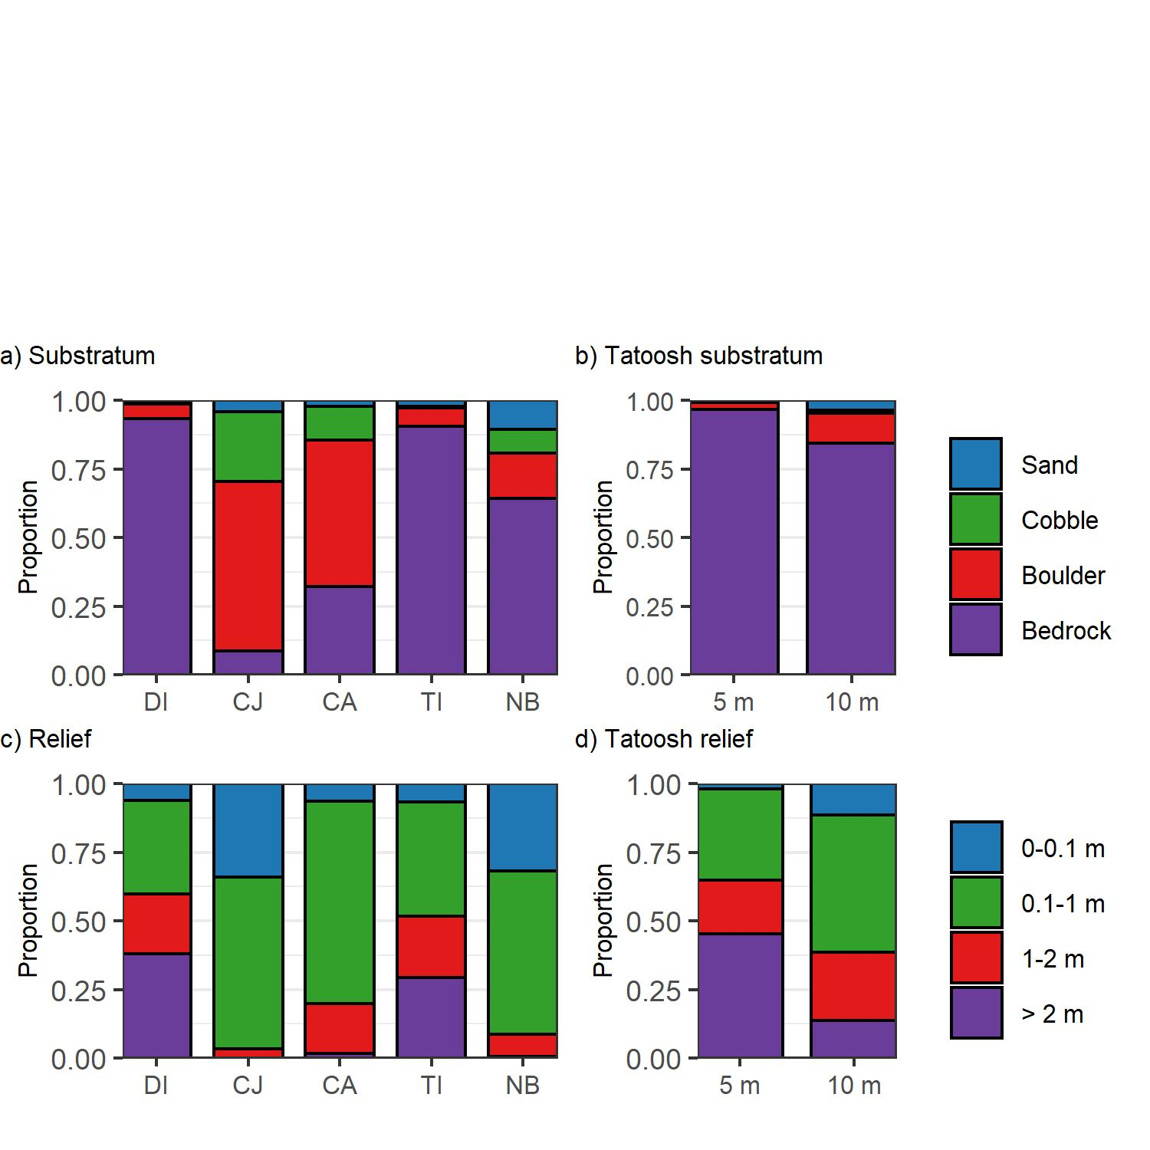

##### Figure S1. Substrate and relief at the five sites: DI = Destruction Island, CJ = Cape Johnson, CA = Cape Alava, TI = Tatoosh Island, NB = Neah Bay and at two depths (5 and 10 m) for Tatoosh Island. Relief categories measure the change in elevation across the width of the 2-m transect.

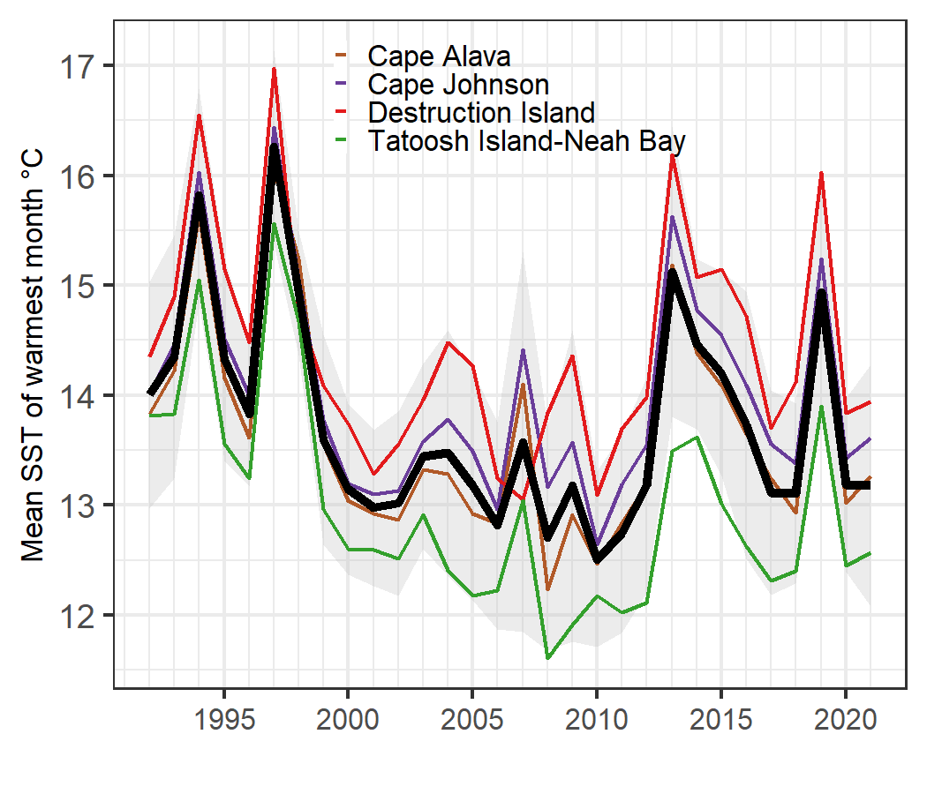

##### Figure S2. Mean maximum monthly SST at the five sites (5-day smooth) from 1992-2021. Note Tatoosh Island and Neah Bay are in the same interpolated grid cell and combined. Black line is the mean across sites and the grey envelope is its 1.0 s.e.

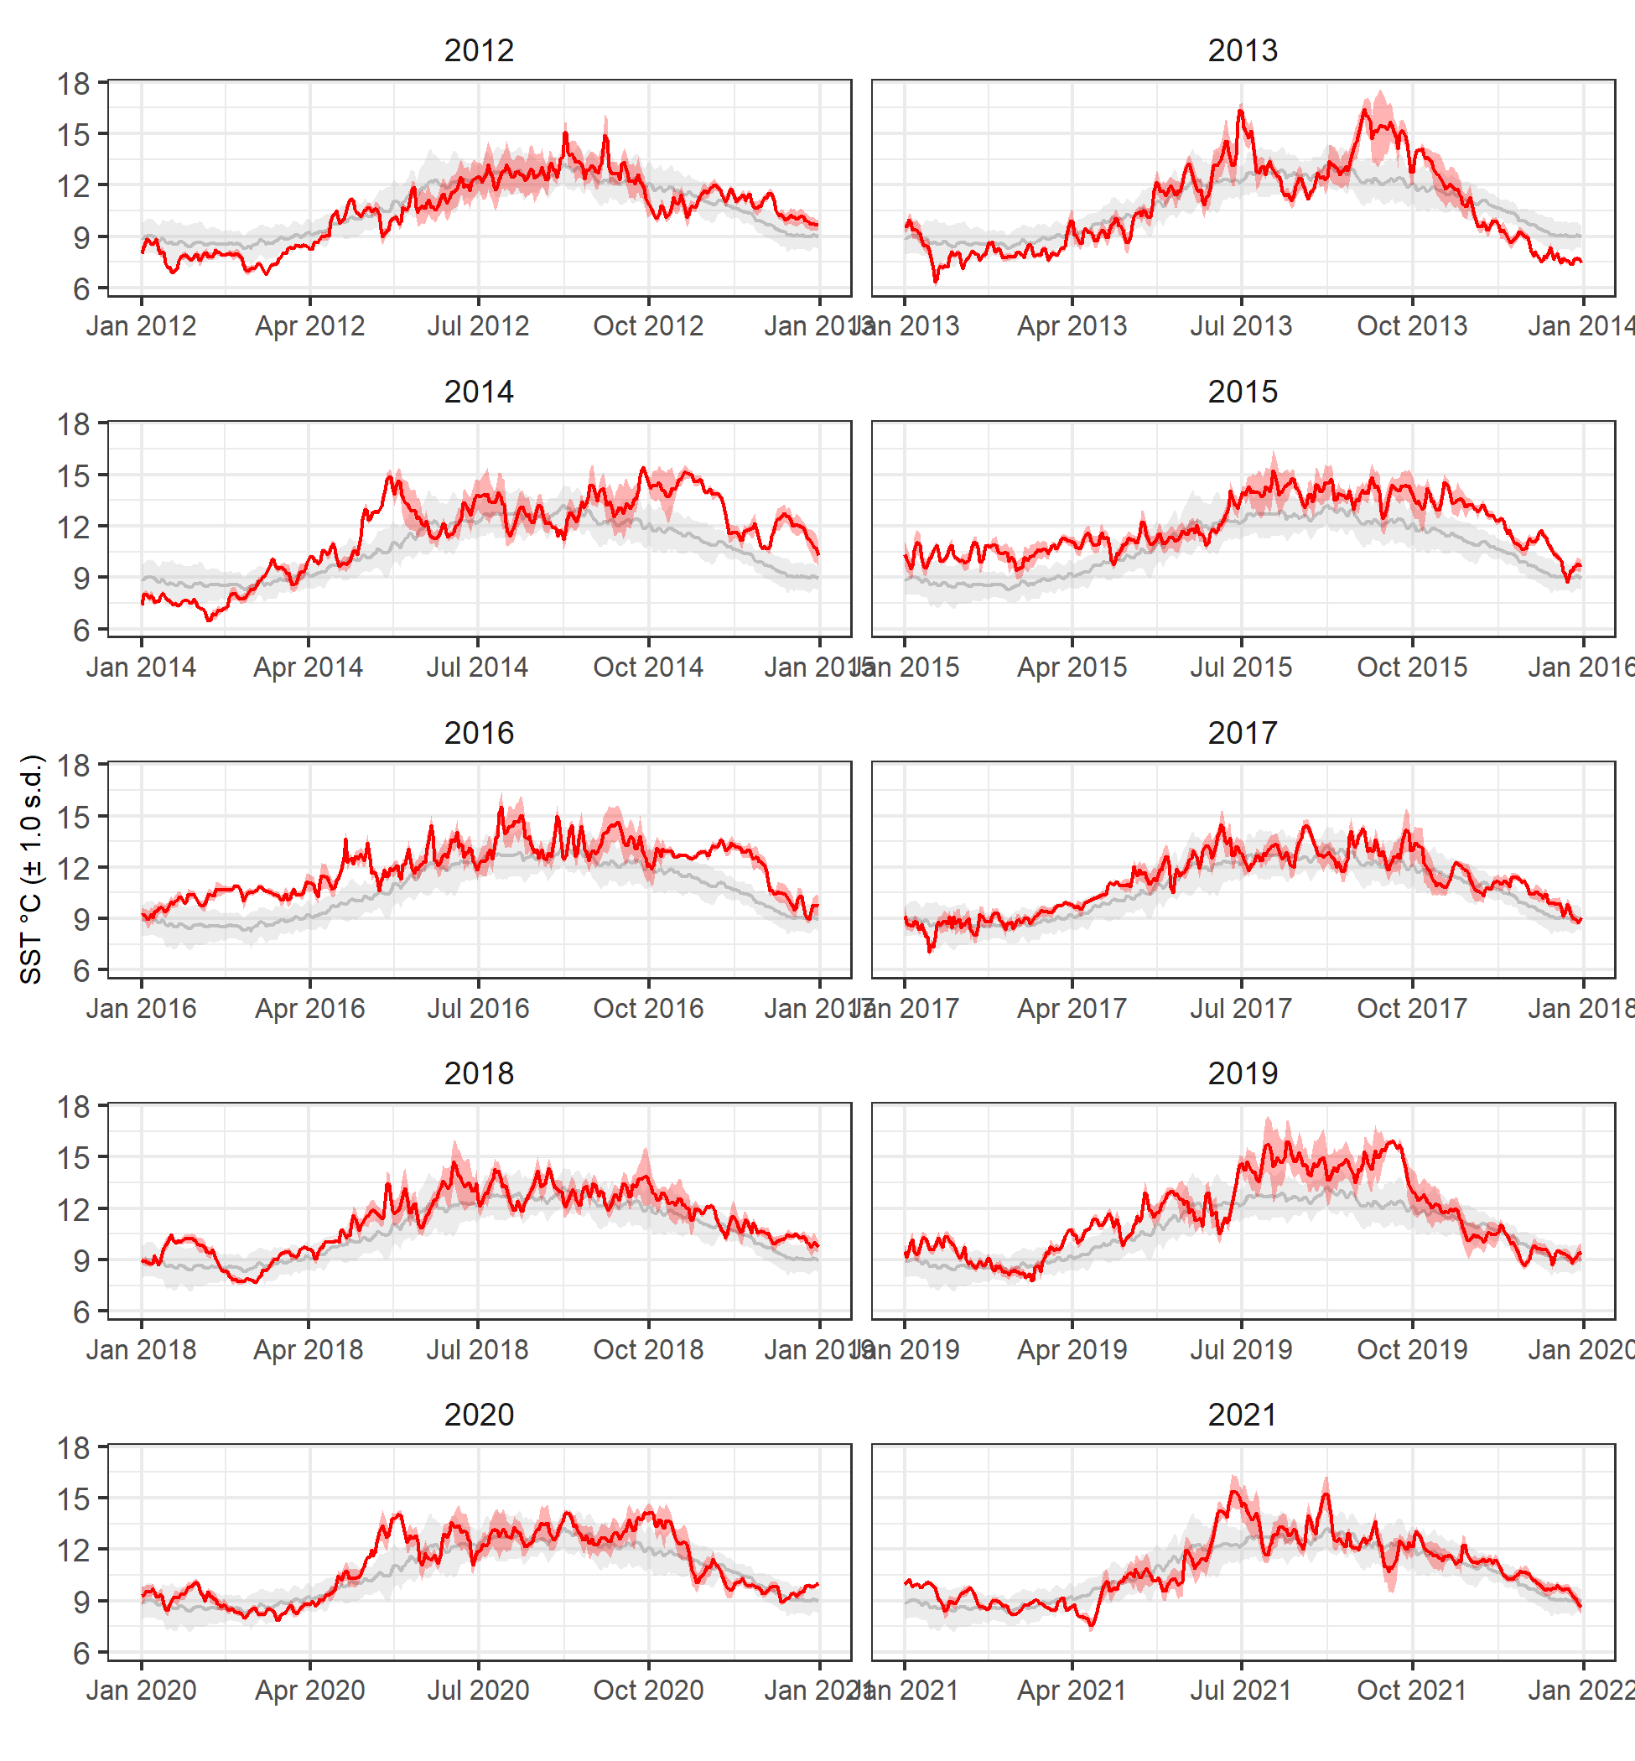

##### Figure S3. Yearly progression of SST for 2012-2021 compared to the average of 1992-2012. Red line is the average across the four sites for each year. Envelopes represent 1.0 s.d.

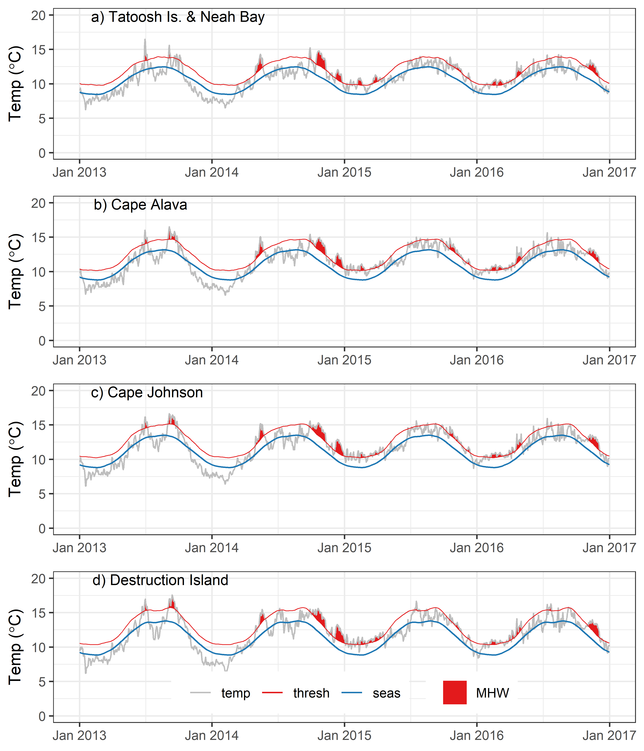

##### Figure S4. Occurrence of marine heatwaves for four locations along the Washington coast from 2013 through 2016. Grey line (temp) indicates observed, daily mean temperature; blue line indicates the 30-year (1992-20221) climatological mean by day of year; red line indicates the 90% threshold; filled areas represent marine heatwaves with 5+ consecutive days above the threshold (Hobday et al. 2016).

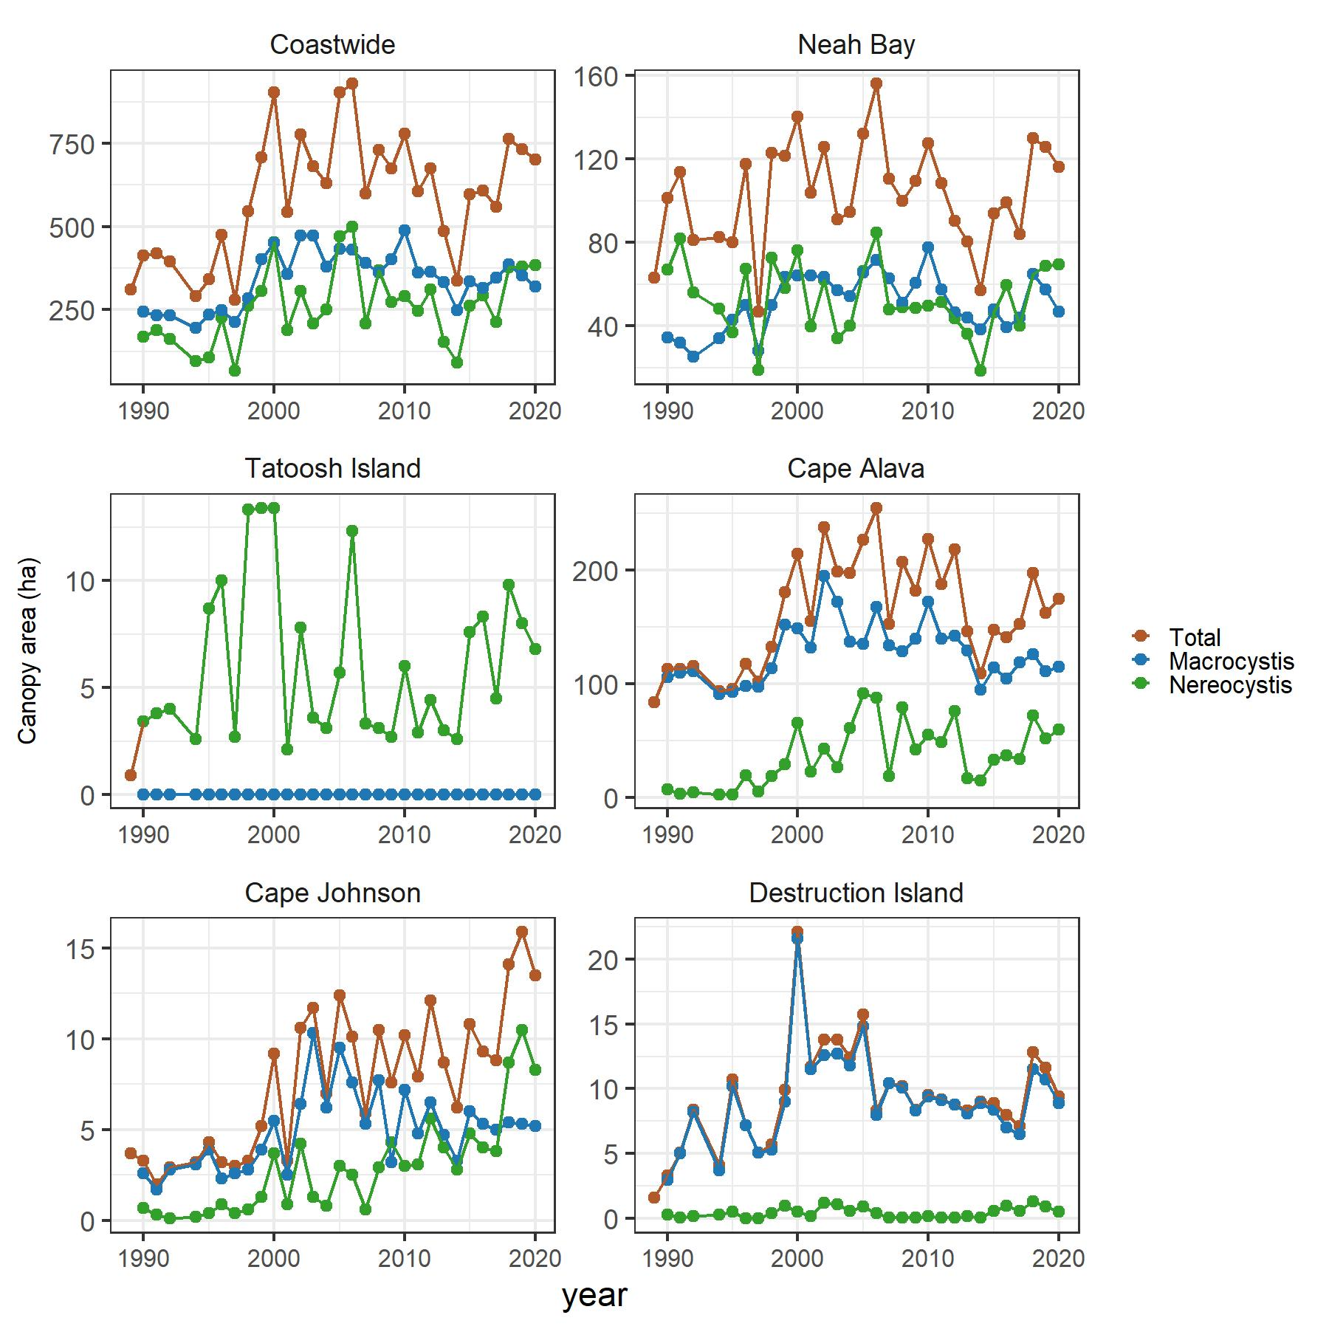

##### Figure S5. Canopy area of *Nereocystis* and *Macrocystis* from 1989 to 2020 coastwide and at five sites along the Washington coast. Canopy area is the spatial extent of kelp blades, stipes and bulbs floating on the water surface (Van Wagenen 2015). Note, there was no *Macrocystis* at Tatoosh Island, so the Total and *Nereocystis* values overlap.

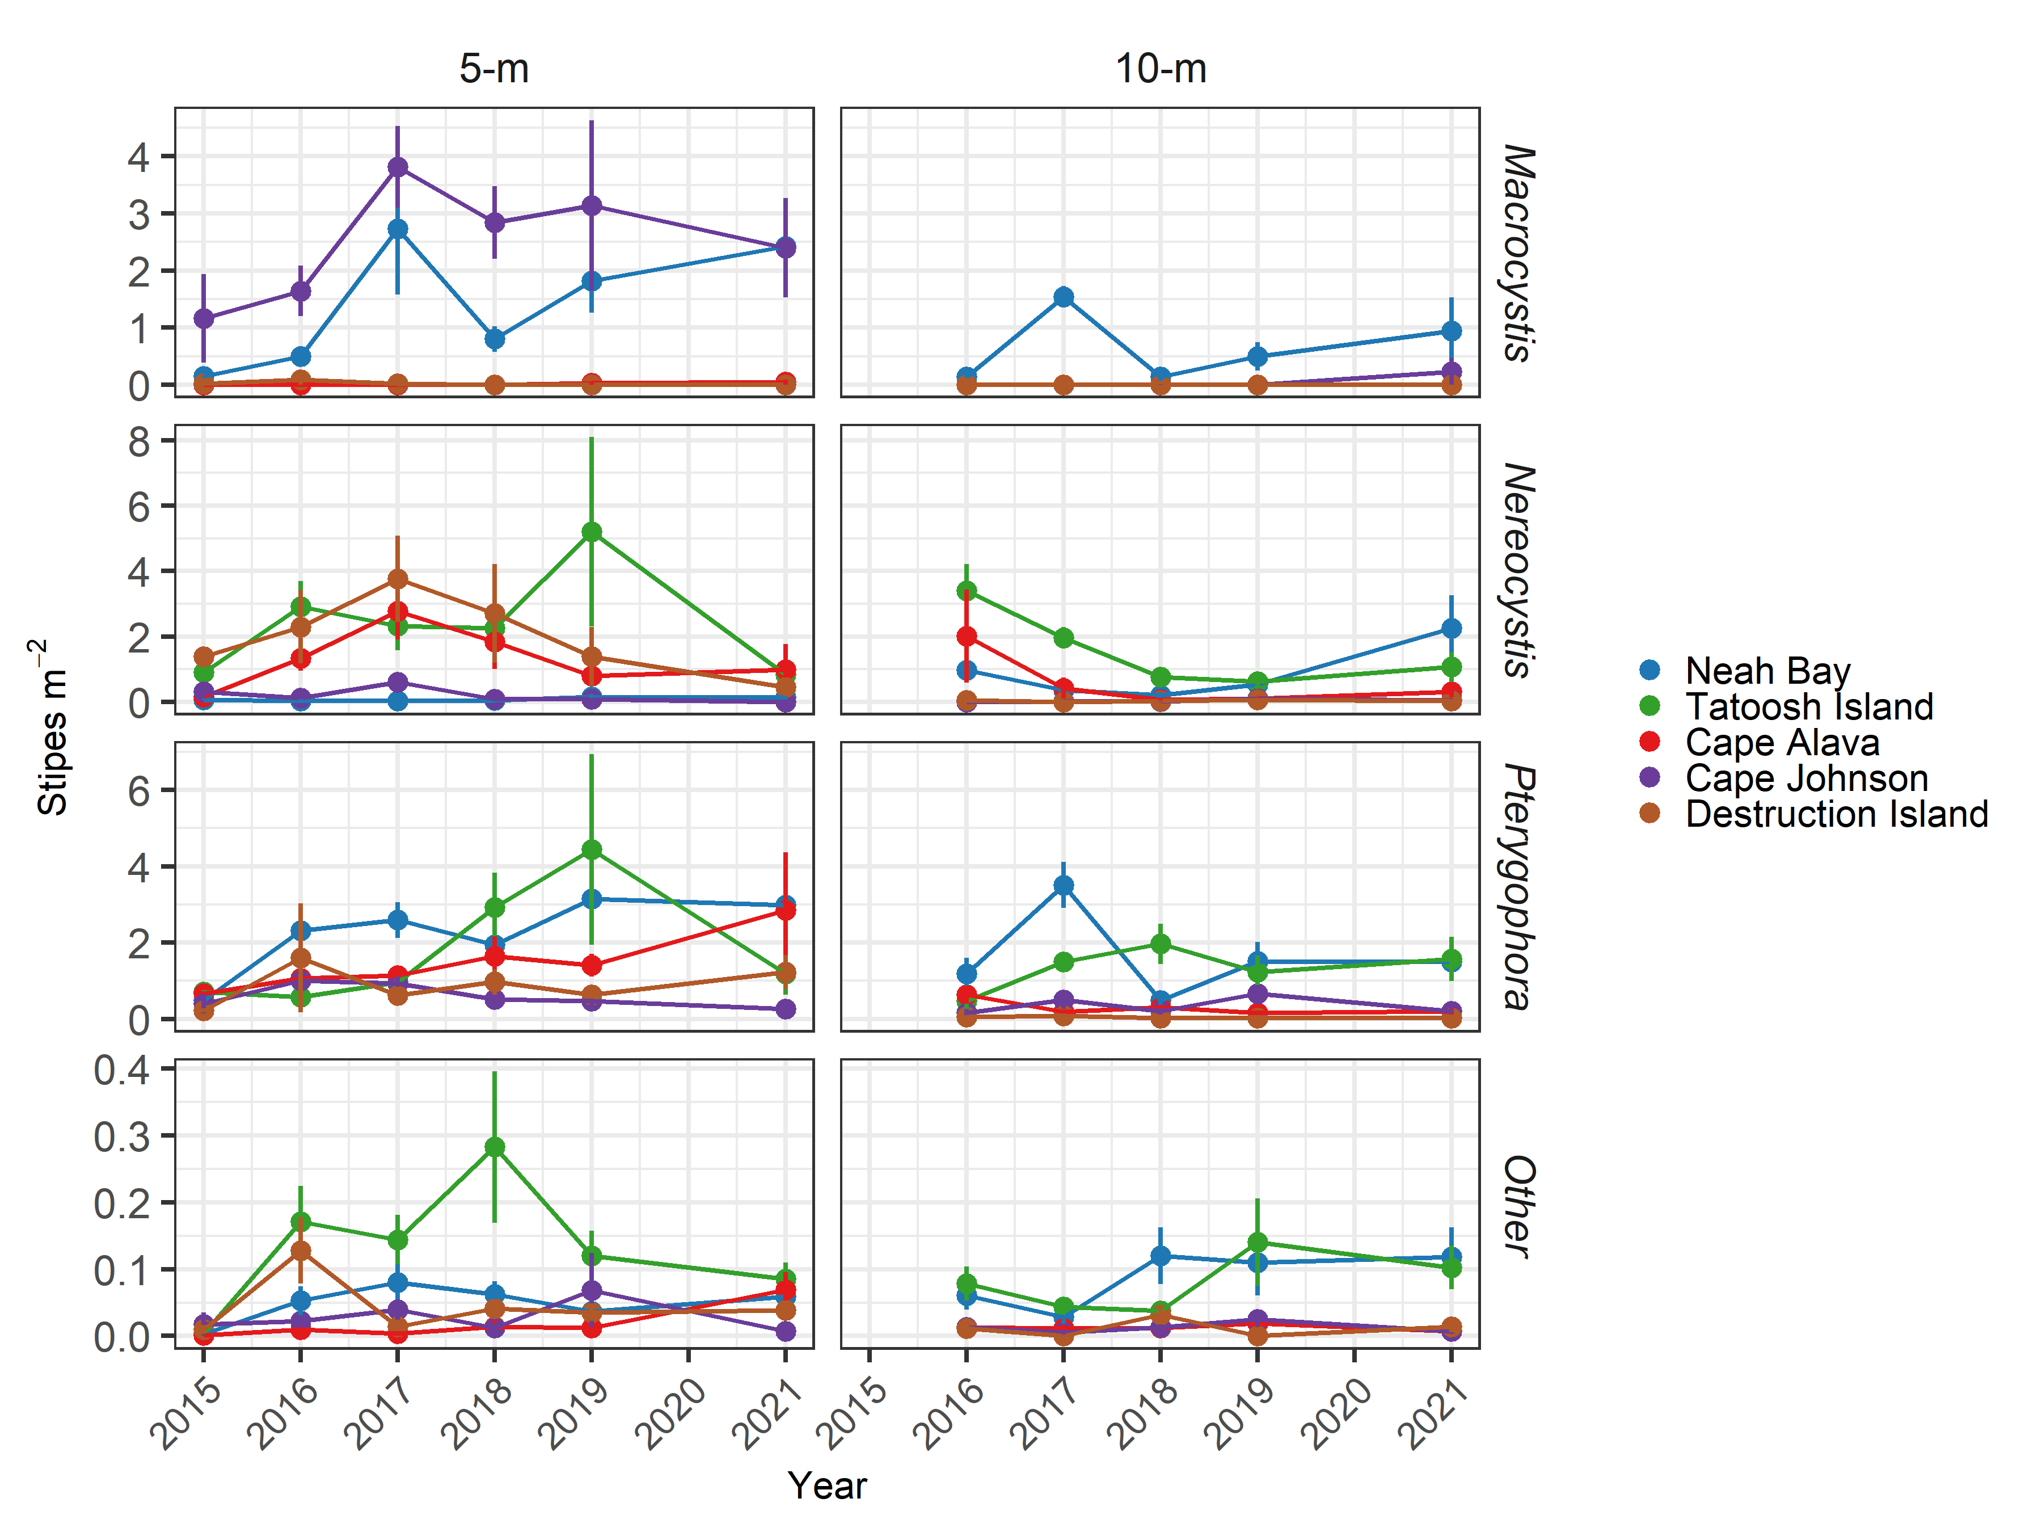

##### Figure S6. Stipe density for the three primary kelps and the sum of other stipitate kelps at five sites and two depths from 2015-2021.

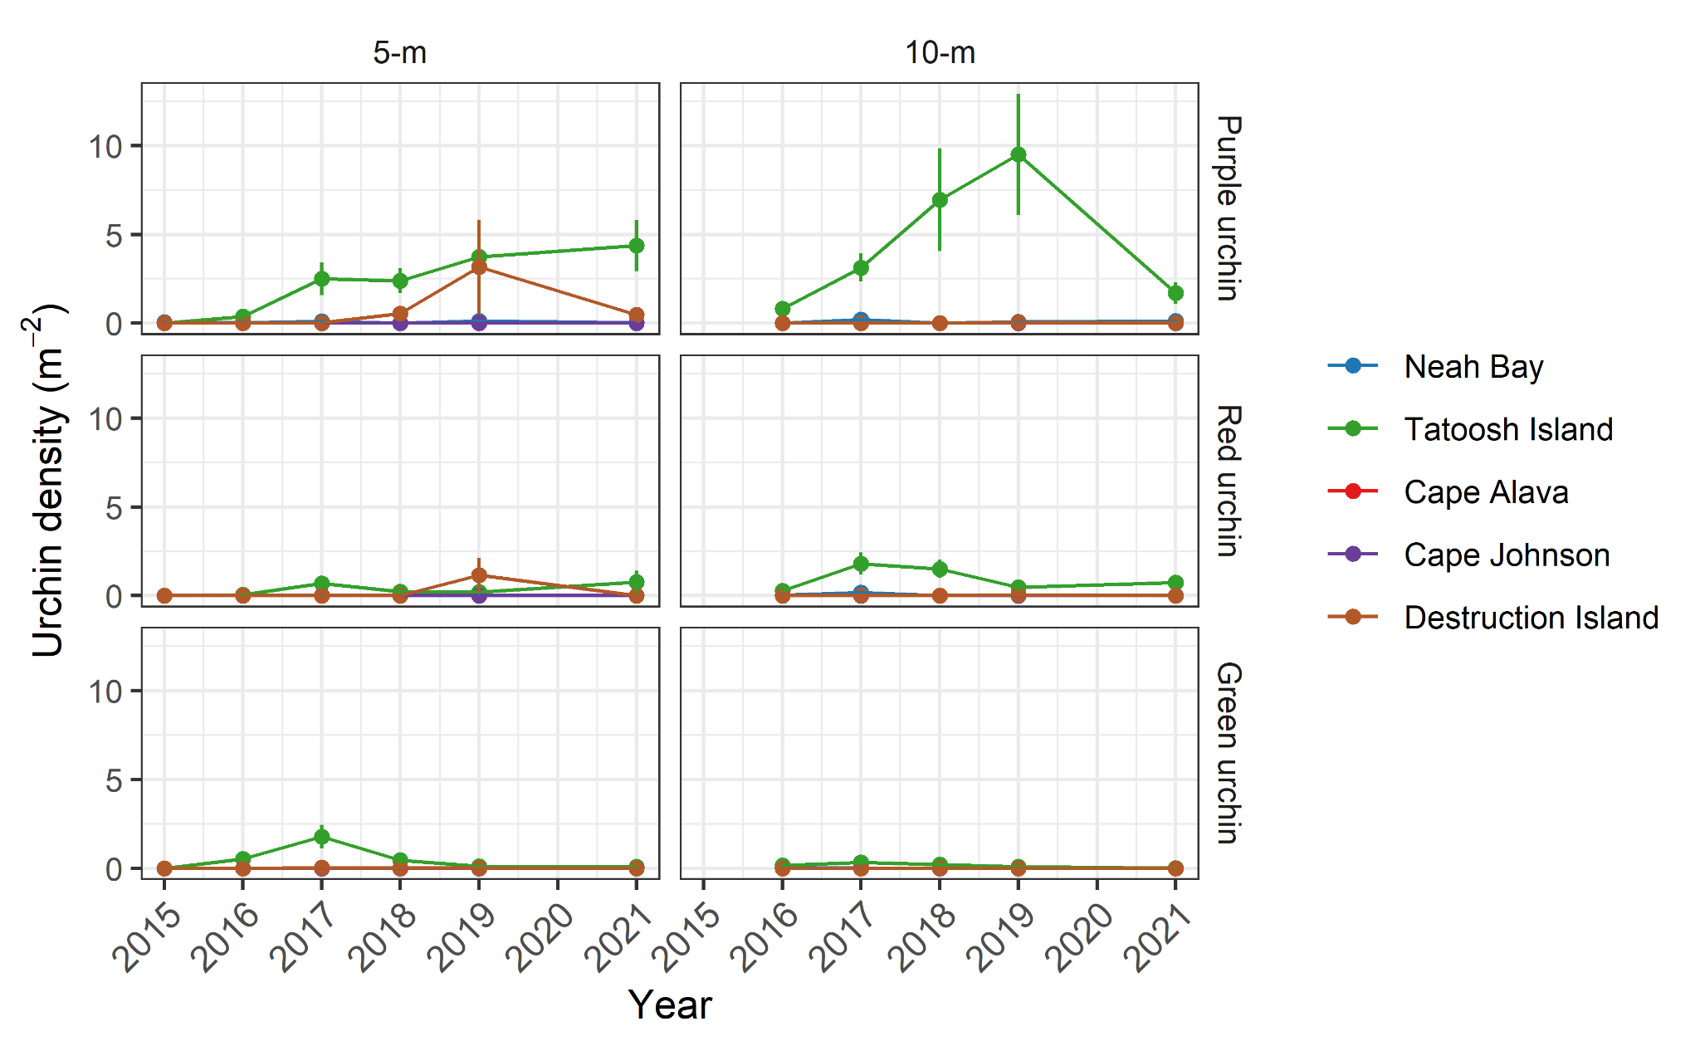

##### Figure S7. Abundance of urchins at five sites and two depths from 2015-2021.

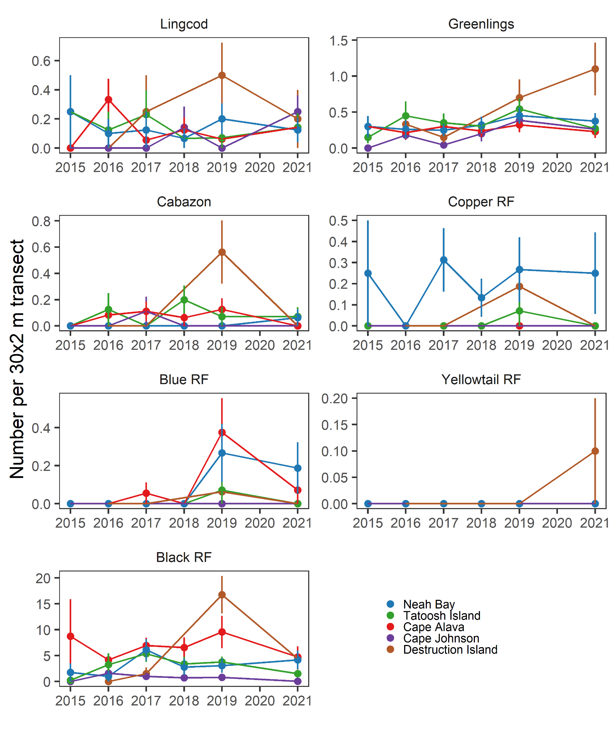

##### Figure S8. Abundance of seven fish species at five sites from 2015-2021.

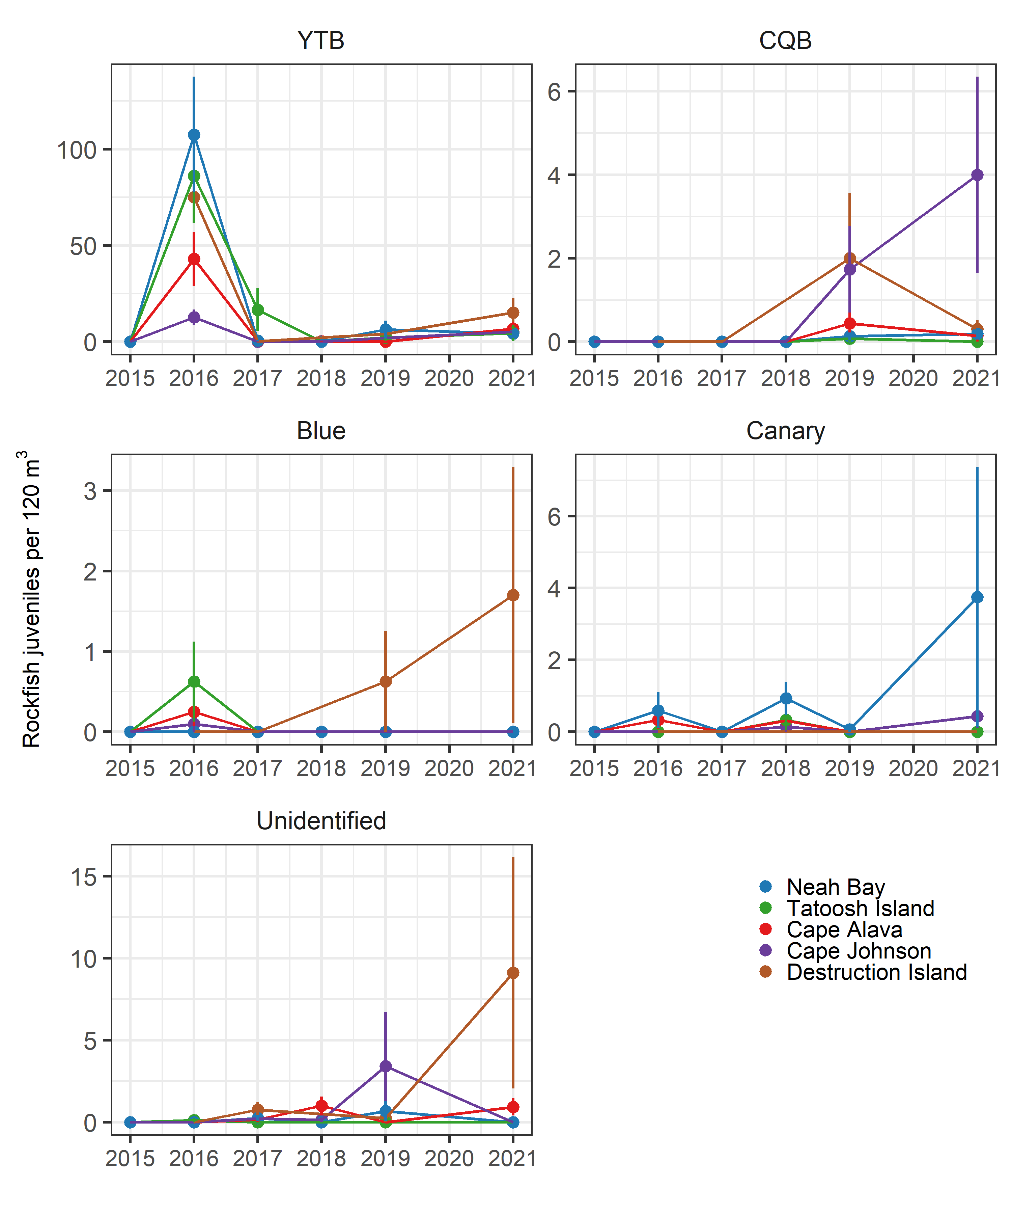

##### Figure S9. Abundance of rockfish young-of-year at five sites from 2015-2021. Note the scales on the y-axes differ. YTB = yellowtail and black rockfishes. CQB = copper, quillback, and brown rockfishes.

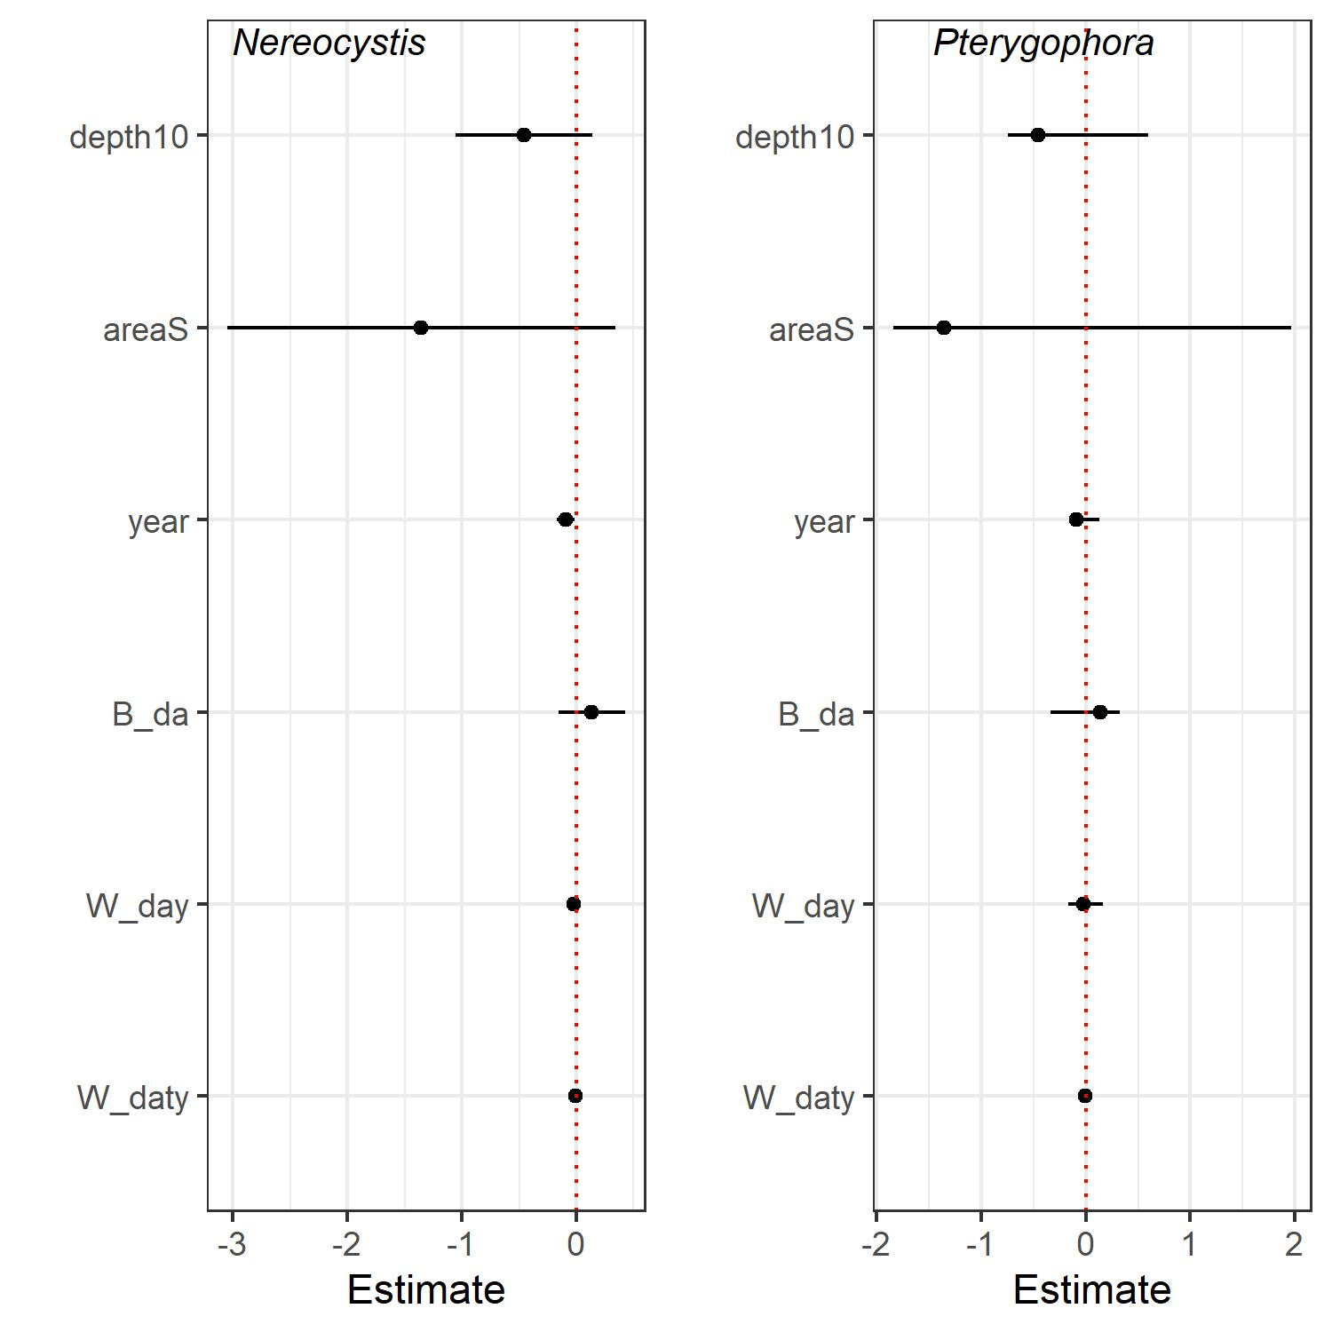

##### Figure S10. Results of REWB models for *Nereocystis* and *Pterygophora* at Tatoosh Island. Data are the parameter estimates for the fixed effects for each model. Error bars are 95% confidence limits. The intercepts are not shown. Dotted red line indicates zero.

# Literature Cited

Hobday AJ, Alexander LV, Perkins SE, Smale DA, Straub SC, Oliver ECJ, Benthuysen JA, Burrows MT, Donat MG, Peng M, Holbrook NJ, Moore PJ, Scannell HA, Sen Gupta A, Wernberg T (2016) A hierarchical approach to defining marine heatwaves. Progress in Oceanography 141:227-238

Malone DP, Davis K, Lonhart SI, Parsons-Field A, Caselle JE, Carr MH (2022) Large scale, multi-decade monitoring data from kelp forest ecosystems in California and Oregon (USA). Ecology n/a:e3630

Pearcy WG, Stein DL, Hixon MA, Pikitch EK, Barss WH, Starr RM (1989) Submersible observations of deep-reef fishes of Heceta Bank Oregon USA. Fishery Bulletin 87:955-966

Stein DL, Tissot BN, Hixon MA, Barss W (1992) Fish-habitat associations on a deep reef at the edge of the Oregon continental-shelf. Fishery Bulletin 90:540-551